**INTRODUCTION**

For Software Engineering project , only 2 member allowed in a group . So , my friend and I , Wan Nazreen and Usamah decide to do BookTaxiOnline for our project . Actually we have a lot of idea to do our project , but we think this is the best according to our ability about coding and also programming . Our project is about how to book taxi through online . But first , we want to explain about our project . Before we want to book taxi , we must open the website first and it will display the statement about link among public university in Klang Valley . So this is the taxi for students that want to move from one university to another university . Thus , we had create company named AWEKITE Incorp in order to manage BookTaxiForU application . Besides , we also aim this application to students so that they can explore more within their university .

The route for the the movement of the taxi had been fixed that are From UIA to UTM , to UPM , to UKM , to UM and USIM also . The fare for the taxi also has been decided . The amount has been calculated based on the distance from UIA to other university . The more futher the distance the more the amount had to pay by students . By this application , students just book through online without having go to the counter to purchase the taxi .

When we open the website , we need to register first by fill in our name and phone number so that the company can contact you easily if there are some problem . Then , we need to choose the route that we want to set . On the other hand , we also can choose what type of car do we want according to our comfortable such as proton perdana , proton persona and also proton saga . There are only proton’s car because proton is our national car .

**USE CASE DIAGRAM**

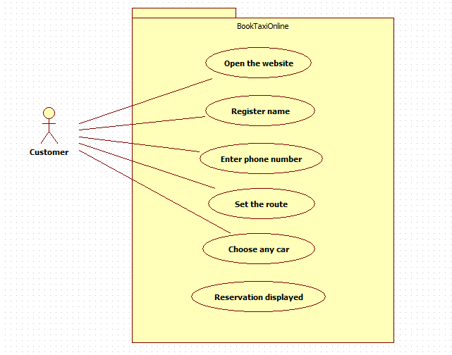

**SEQUENCE DIAGRAM**

**(i)**

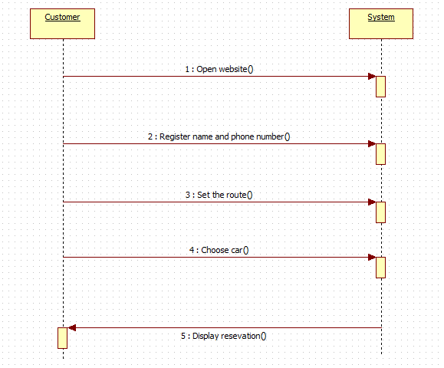

**(ii)**

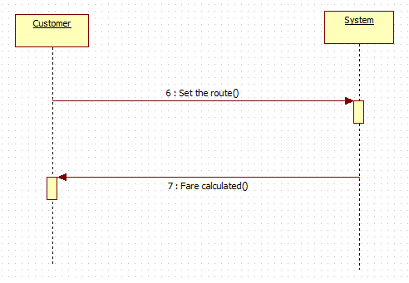

**ACTIVITY DIAGRAM**

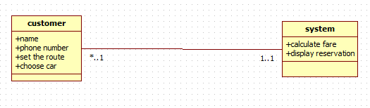

**Print screen of the system**

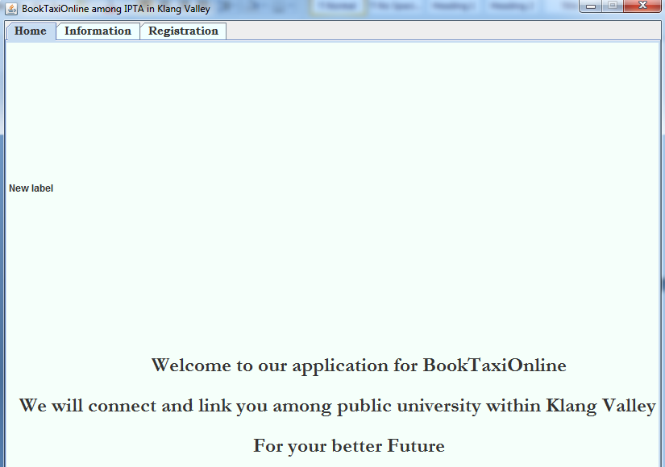

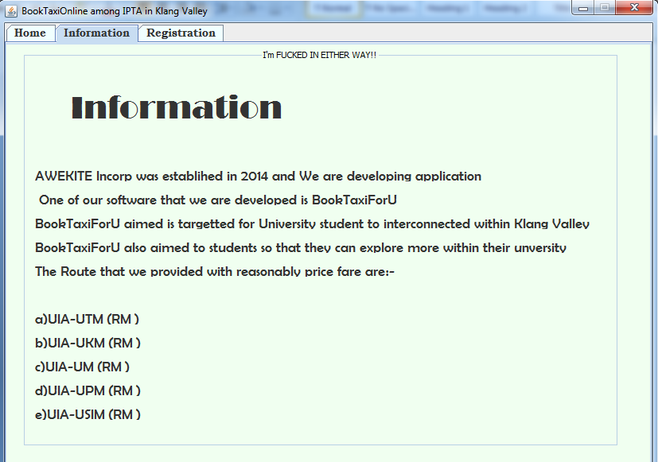

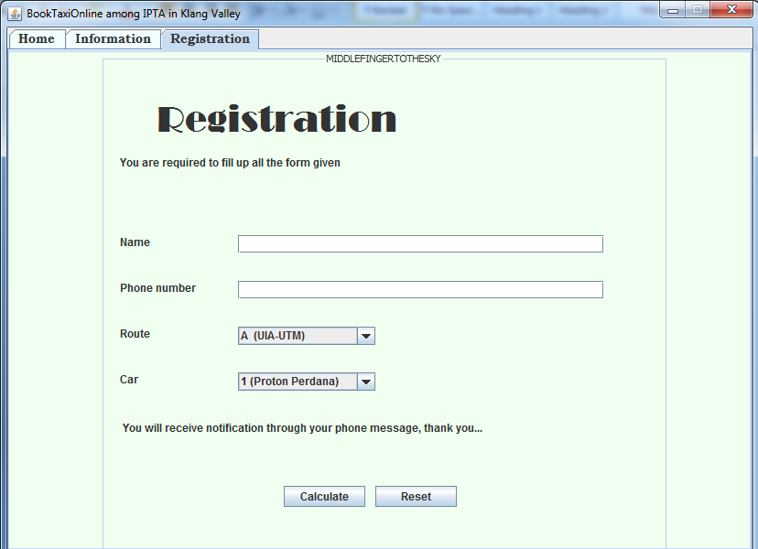

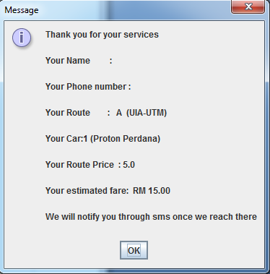

**Conclusion**

As a conclusion , this BookTaxiForU application is so important for the students to get know more about other university . This application can provide accommodation for students in order to visit or meet some friends in other university such as UM , UPM and so on . Students just book through online by registering the name and phone number and they choose the destination and type of car they prefer and then finish . It is more easier than other application . They do not have to go around to buy ticket for taxi or bus to go anywhere . They will save their money and also energy .

Last but not least , as technology become develop from day to day and all the application nowadays using more network and internet , so we suggest to students to learn and apply all the application that have been prepared such as BookTaxiForU . We confidence that this application can give a lot of benefits for students in future .